Web Technologists for Bioinformatics

Dharineesh K S

123013012

Task 1: HTML Coding

Question number - 01

**<!DOCTYPE html>**

**<html lang="en">**

**<head>**

**<meta charset="UTF-8">**

**<title>Qn - 1</title>**

**</head>**

**<body>**

**<h2>Qn - 1</h2>**

**<ul>**

**<li>**

**<strong>**

**Coffee**

**</strong>**

**</li>**

**<li>**

**<strong>**

**Tea**

**</strong>**

**</li>**

**<ul type="circle">**

**<li>**

**Black Tea**

**</li>**

**<li>**

**Green Tea**

**</li>**

**</ul>**

**</ul>**

**</body>**

**</html>**

Output:

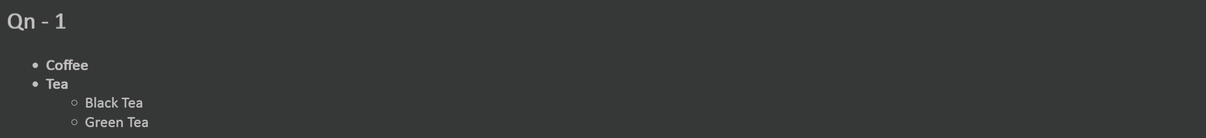

Question number – 02

**<!DOCTYPE html>**

**<html lang="en">**

**<head>**

**<meta charset="UTF-8">**

**<title>Qn - 2</title>**

**</head>**

**<body>**

**<table align="center" >**

**<tr>**

**<td></td>**

**<th>Registration form</th>**

**</tr>**

**<tr>**

**<td align="right">username</td>**

**<td><input type = "text" name ="username" ></td>**

**</tr>**

**<tr>**

**<td align="right">password</td>**

**<td><input type="password" name="password" >**

**</td>**

**</tr>**

**<tr>**

**<td>confirm password </td>**

**<td><input type="password" name="password" >**

**</td>**

**</tr>**

**<tr>**

**<td align="right">first name</td>**

**<td><input type = "text" name ="firstname" >**

**</td>**

**</tr>**

**<tr>**

**<td align="right">lastname </td>**

**<td><input type = "text" name ="lastname" >**

**</td>**

**</tr>**

**<tr>**

**<td align="right">Email </td>**

**<td><input type = "email" name ="mail" >**

**</td>**

**</tr>**

**<tr>**

**<td align="right">phone number </td>**

**<td><input type="text" name ="username" >**

**</td>**

**</tr>**

**<tr>**

**<td align="right">location</td>**

**<td><input type="text" name ="loc" >**

**</td>**

**</tr>**

**<tr>**

**<td></td>**

**<td align="center" ><input type="button" name="save" value="save">**

**<input type="reset" name="reset" value="reset"></td>**

**</table>**

**</body>**

**</html>**

Output:



Question number – 03

**<!DOCTYPE html>**

**<html lang="en">**

**<head>**

**<meta charset="UTF-8">**

**<title>Qn - 3</title>**

**</head>**

**<body>**

**<h2>Qn - 3</h2>**

**<table border="1" cellpadding="20">**

**<tr>**

**<th>Country</th>**

**<th colspan="2">Population (in Crores)</th>**

**</tr>**

**<tr>**

**<td rowspan="3" align="right">INDIA</td>**

**<td align="right">1998</td>**

**<td align="right">85</td>**

**</tr>**

**<tr>**

**<td align="right">1999</td>**

**<td align="right">90</td>**

**</tr>**

**<tr>**

**<td align="right">2000</td>**

**<td align="right">100</td>**

**</tr>**

**<tr>**

**<td rowspan="3" align="right">USA</td>**

**<td align="right">1998</td>**

**<td align="right">30</td>**

**</tr>**

**<tr>**

**<td align="right">1999</td>**

**<td align="right">35</td>**

**</tr>**

**<tr>**

**<td align="right">2000</td>**

**<td align="right">40</td>**

**</tr>**

**<tr>**

**<td rowspan="2" align="right">UK</td>**

**<td align="right">1998</td>**

**<td align="right">25</td>**

**</tr>**

**<tr>**

**<td align="right">1999</td>**

**<td align="right">30</td>**

**</tr>**

**</table>**

**</body>**

**</html>**

Output:

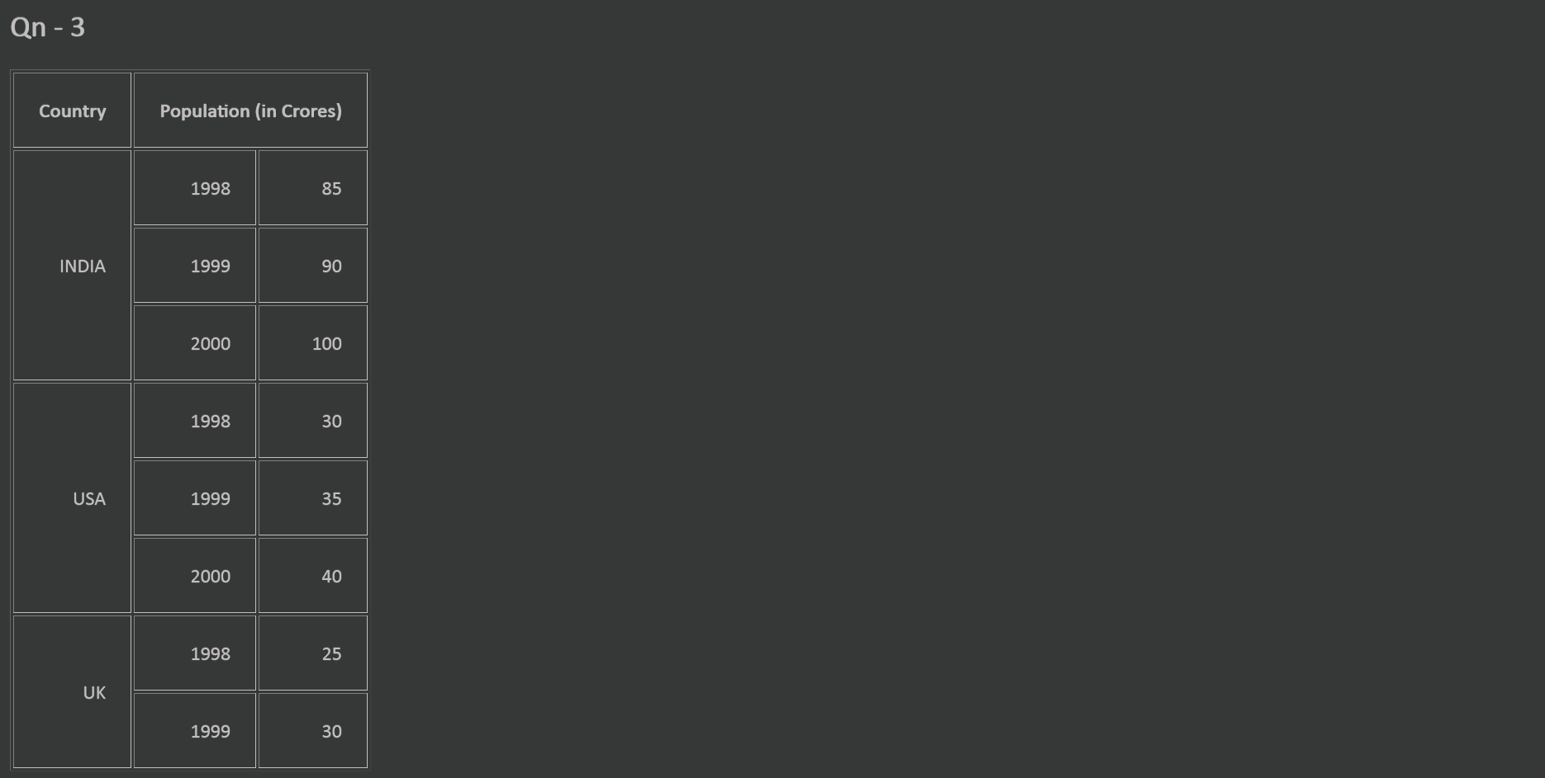

Question number - 04

**<!DOCTYPE html>**

**<html lang="en">**

**<head>**

**<meta charset="UTF-8">**

**<title>Qn - 4</title>**

**</head>**

**<body>**

**<h2>Qn - 4</h2>**

**<h2 align="center">Text formatting tags of html</h2>**

**<ol>**

**<li><b>Text will be bold </b>- (b tag)</li>**

**<li><i>Text will be italics </i>- (i tag)</li>**

**<li><u>Text will be underlined </u>- (u tag)</li>**

**<li><strong>Text will be bold </strong>- important text(strong tag)</li>**

**<li><em>Text will be italics </em>- emphasized text(em tag)</li>**

**</ol>**

**</body>**

**</html>**

Output:

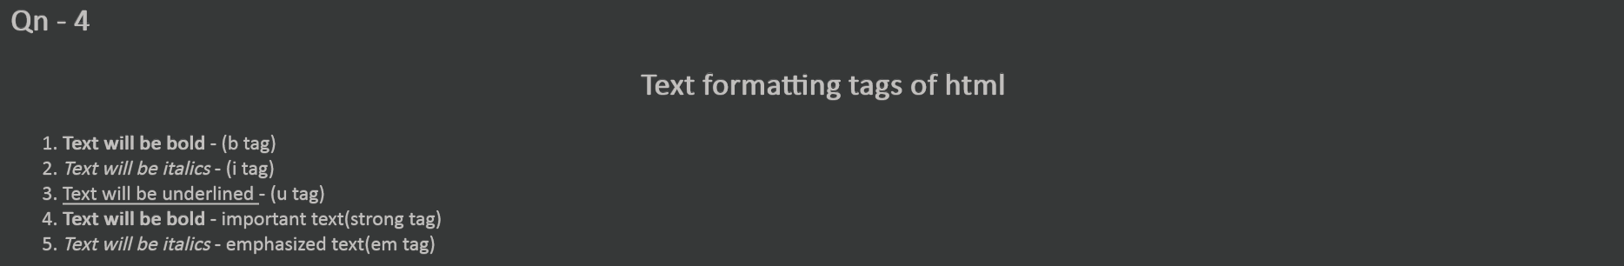

Question number - 05

**<!DOCTYPE html>**

**<html lang="en">**

**<head>**

**<meta charset="UTF-8">**

**<title>Qn - 5</title>**

**</head>**

**<body>**

**<form>**

**<p>**

**Enter Name of your friend**

**<input type="text" name="name">**

**</p>**

**<p>**

**choose the file you want to post to your friend**

**</p>**

**<p>**

**<input type="text" name="files">**

**<input type="file" value="browse">**

**</p>**

**<p> What does the file contain ? </p>**

**<input type="checkbox"> image**

**<input type="checkbox"> Source code**

**<input type="checkbox"> Binary code**

**<p>**

**You have completed the form**

**<input type="submit" value="Submit Query">**

**</p>**

**</form>**

**</body>**

**</html>**

Output:

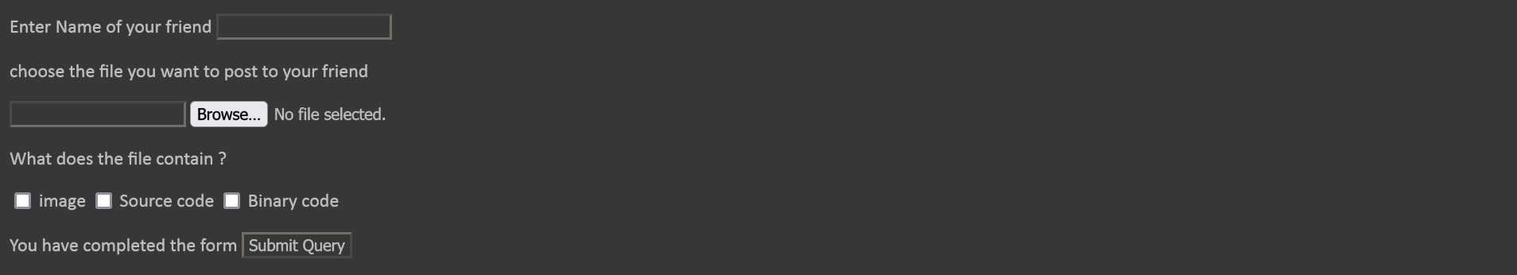

Question number - 06

**<!DOCTYPE html>**

**<html lang="en">**

**<head>**

**<meta charset="UTF-8">**

**<title>Qn - 6</title>**

**</head>**

**<body>**

**<h2>Qn - 6</h2>**

**<table border="1" cellpadding="1">**

**<tr>**

**<th>Organisation</th>**

**<th>Website</th>**

**</tr>**

**<tr>**

**<td>LOK SEWA AAYOG</td>**

**<td><a href="www.psec.gov.np" target="_blank">www.psec.gov.np</a></td>**

**</tr>**

**<tr>**

**<td>HSEB</td>**

**<td><a href="www.hseb.edu.np" target="_blank">www.hseb.edu.np</a></td>**

**</tr>**

**<tr>**

**<td>TU</td>**

**<td><a href="www.tu.edu.np" target="_blank">www.tu.edu.np</a></td>**

**</tr>**

**</table>**

**</body>**

**</html>**

Output:

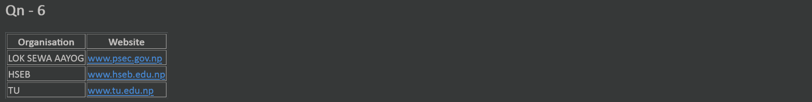

Question number - 07

**<!DOCTYPE html>**

**<html lang="en">**

**<head>**

**<meta charset="UTF-8">**

**<title>Qn - 7</title>**

**</head>**

**<body>**

**<h2> Qn - 7</h2>**

**<br>**

**<table border="1" cellpadding="5">**

**<tr>**

**<th>A</th>**

**<th colspan="3">B</th>**

**</tr>**

**<tr>**

**<td>C</td>**

**<td colspan="2">D</td>**

**<td>E</td>**

**</tr>**

**<tr>**

**<td colspan="2">F</td>**

**<td></td>**

**<td>G</td>**

**</tr>**

**</table>**

**</body>**

**</html>**

Output:

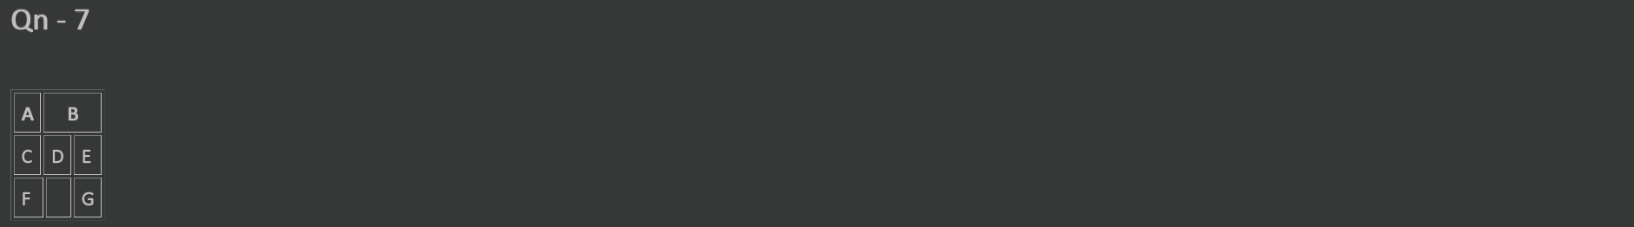

Question number - 08

**<!DOCTYPE html>**

**<html lang="en">**

**<head>**

**<meta charset="UTF-8">**

**<title>Qn - 8</title>**

**</head>**

**<body bgcolor = “blue”>**

**<h1> Qn - 8 </h1>**

**<center>**

**<a href="https://webstream.sastra.edu/sastrapwi/images/sastra_logo_1.gif" target="_blank">**

**<font color="red">**

**https://webstream.sastra.edu/sastrapwi/images/sastra_logo_1.gif**

**</font>**

**</a>**

**<br>**

**<br>**

**<br>**

**<img src="https://webstream.sastra.edu/sastrapwi/images/sastra_logo_1.gif">**

**</center>**

**</body>**

**</html>**

Output:



Question number - 09

**The <font> tag is not supported in the HTML5 browser.**

Question number - 10

**<!DOCTYPE html>**

**<html lang="en">**

**<head>**

**<meta charset="UTF-8">**

**<title>Qn - 10</title>**

**</head>**

**<body>**

**<h2>Qn - 10</h2>**

**<pre>**

**(01)<sup>2</sup> = 001**

**(02)<sup>2</sup> = 004**

**(03)<sup>2</sup> = 009**

**(04)<sup>2</sup> = 016**

**(05)<sup>2</sup> = 025**

**(06)<sup>2</sup> = 036**

**(07)<sup>2</sup> = 049**

**(08)<sup>2</sup> = 064**

**(09)<sup>2</sup> = 081**

**(10)<sup>2</sup> = 100**

**(11)<sup>2</sup> = 121**

**(12)<sup>2</sup> = 144**

**(13)<sup>2</sup> = 169**

**(14)<sup>2</sup> = 196**

**(15)<sup>2</sup> = 225**

**(16)<sup>2</sup> = 256**

**(17)<sup>2</sup> = 289**

**(18)<sup>2</sup> = 324**

**(19)<sup>2</sup> = 361**

**(20)<sup>2</sup> = 400**

**</pre>**

**</body>**

**</html>**

Output:

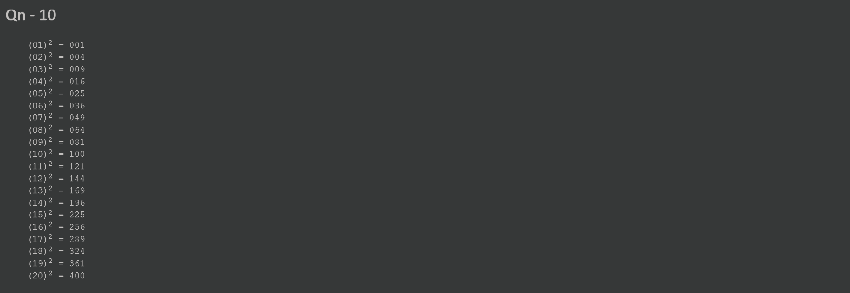

Question number - 11

**<!DOCTYPE html>**

**<html lang="en">**

**<head>**

**<meta charset="UTF-8">**

**<title>Qn - 11</title>**

**</head>**

**<body>**

**<h2>Qn - 11</h2>**

**<h1>HTML</h1>**

**<hr width="100%">**

**<p>**

**HTML is the standard markup language for Web pages.**

**With HTML, you can create your own Website.**

**HTML is easy to learn - You will enjoy it!**

**</p>**

**</body>**

**</html>**

Output:

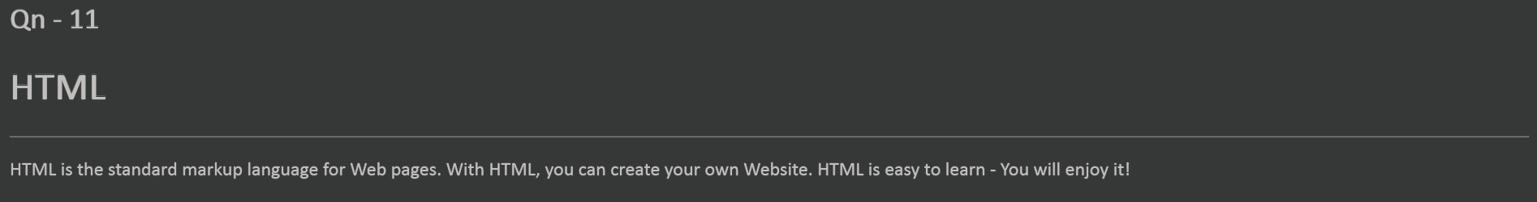

Question number - 12

**<!DOCTYPE html>**

**<html lang="en">**

**<head>**

**<meta charset="UTF-8">**

**<title>Qn - 12</title>**

**</head>**

**<body>**

**<h1> Qn - 12</h1>**

**<dl>**

**<dt>HTML:</dt>**

**<dd>**

**HTML stands for Hyper Text Markup Language.**

**HTML is the standard markup language for creating Web pages.**

**HTML describes the structure of a Web page**

**</dd>**

**<dt>CSS:</dt>**

**<dd>**

**CSS is the acronym of “Cascading Style Sheets”.**

**CSS is a computer language for laying out and structuring web pages (HTML or XML).**

**</dd>**

**<dt>Javascript:</dt>**

**<dd>**

**Javascript is an Object-Oriented Programming scripting language.**

**JavaScript code is run on a browser only.**

**</dd>**

**<dt>PHP:</dt>**

**<dd>**

**PHP (Hypertext Preprocessor) is known as a general-purpose scripting language that**

**can be used to develop dynamic and interactive websites.**

**It was among the first server-side languages that could be embedded into HTML,**

**making it easier to add functionality to web pages without needing to call external files for data.**

**</dd>**

**<dt>MYSQL:</dt>**

**<dd>**

**MySQL is a relational database management system based on SQL – Structured Query Language.**

**The application is used for a wide range of purposes, including data warehousing,**

**e-commerce, and logging applications.**

**</dd>**

**</dl>**

**</body>**

**</html>**

Output:

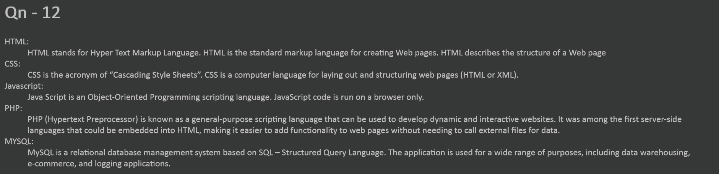

Question number - 13

**<!DOCTYPE html>**

**<html lang="en">**

**<head>**

**<meta charset="UTF-8">**

**<title>Qn - 13</title>**

**</head>**

**<body>**

**<h1>Qn - 13</h1>**

**<a href="https://www.google.com/" target="_blank">Search with google</a>**

**<br>**

**<a href="https://duckduckgo.com/" target="_blank">Search with duckduckgo</a>**

**<br>**

**<a href="https://in.search.yahoo.com/?fr2=inr" target="_blank">Search with yahoo</a>**

**<br>**

**<a href="https://www.lycos.com/" target="_blank">Search with lycos</a>**

**<br>**

**<a href="https://www.bing.com/" target="_blank">Search with bing</a>**

**<br>**

**</body>**

**</html>**

Output:

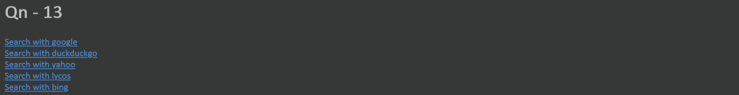

Question number - 14

**<!DOCTYPE html>**

**<html lang="en">**

**<head>**

**<meta charset="UTF-8">**

**<title>Qn - 14</title>**

**</head>**

**<body>**

**<h2>Qn - 14</h2>**

**<a href="#bottom"> Click here to go to bottom of the page</a>**

**<pre>**

**<p id="bottom">This is bottom of the page</p>**

**</pre>**

**</body>**

**</html>**

Output:

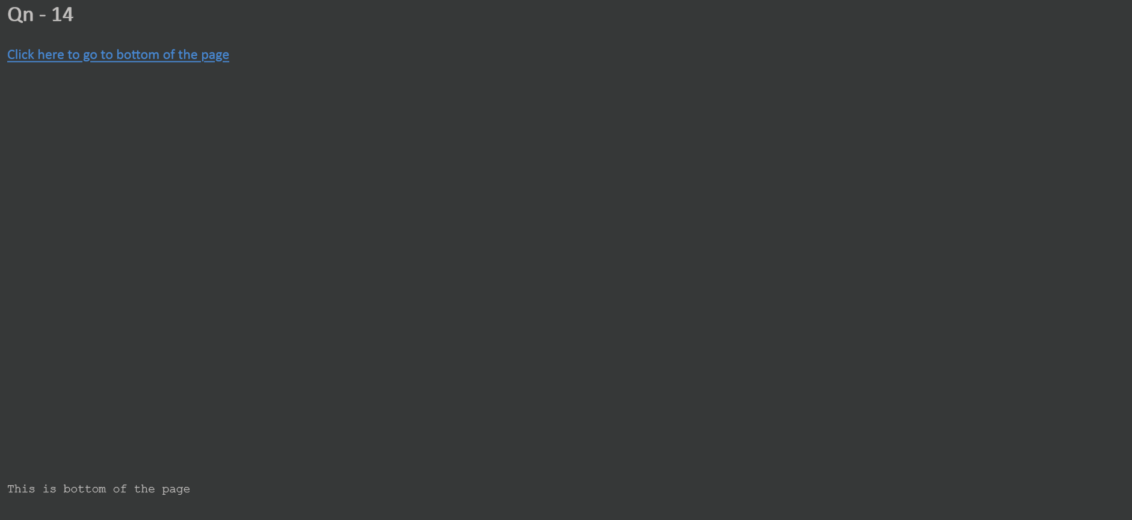

Question number - 15

**<!DOCTYPE html>**

**<html lang="en">**

**<head>**

**<meta charset="UTF-8">**

**<title>Qn - 15</title>**

**</head>**

**<body>**

**<h1>Qn - 15</h1>**

**<img src="https://cdn.rcsb.org/rcsb-pdb/v2/common/images/rcsb_logo.png" border="2" width="200" height="200">**

**</body>**

**</html>**

Output:



Question number - 16

**<!DOCTYPE html>**

**<html lang="en">**

**<head>**

**<meta charset="UTF-8">**

**<title>Qn - 16</title>**

**</head>**

**<body>**

**<h2 align="center"><a href="D:\OneDrive\codes\web\labs\About_Us.html" target="_blank">About Us</a></h2>**

**<h2 align="center"><a href="D:\OneDrive\codes\web\labs\Our_Service.html" target="_blank">Our Service</a></h2>**

**<h2 align="center"><a href="D:\OneDrive\codes\web\labs\Contact_Us.html" target="_blank">Contact US</a></h2>**

**</body>**

**</html>**

Output:

